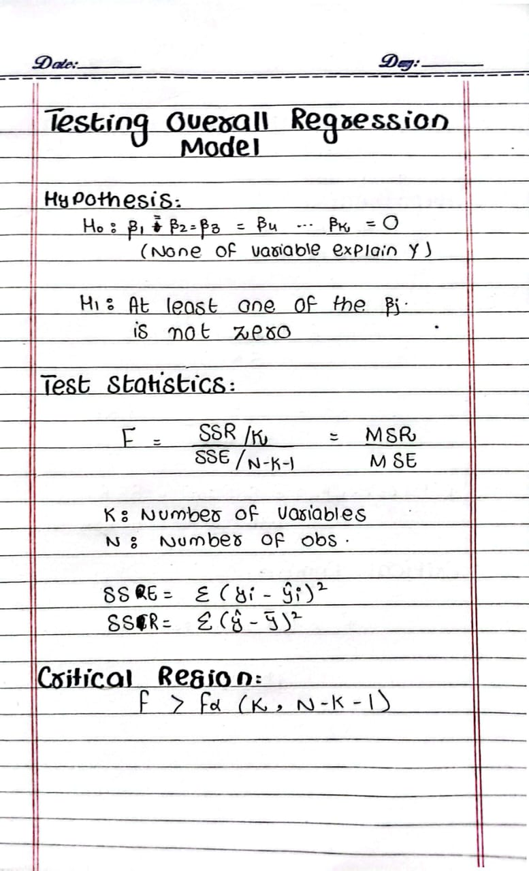
ERROR:
V1= 1
BUT K ! = 1
K= NUMBER OF VARIABLES IN FULL MODEL
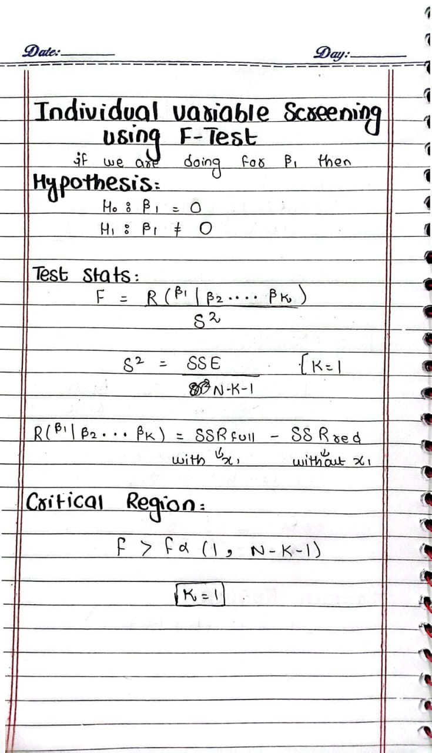

ERROR:
V1= 2
BUT K ! = 2
K= NUMBER OF VARIABLES IN FULL MODEL

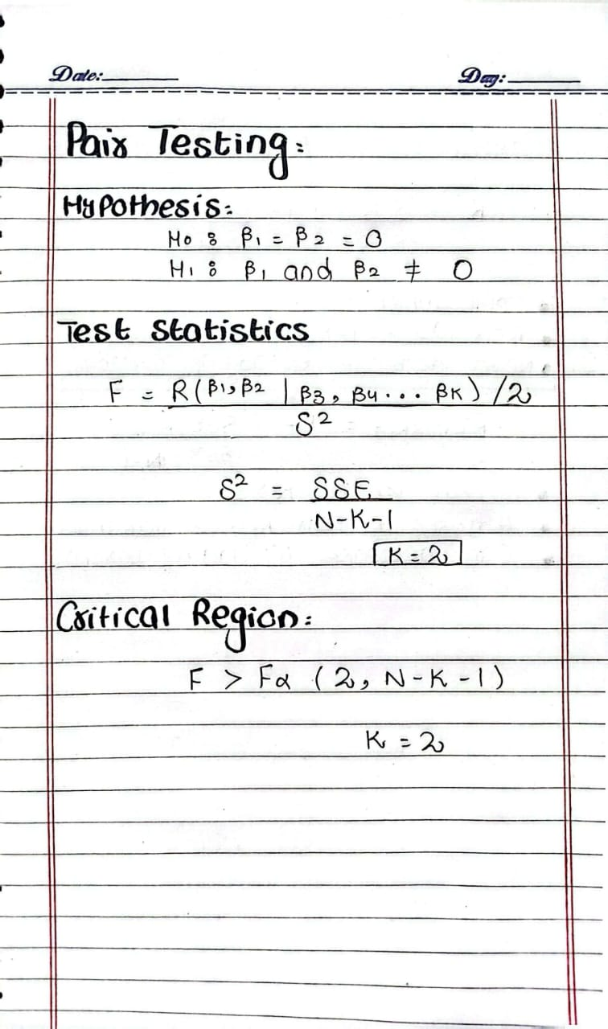

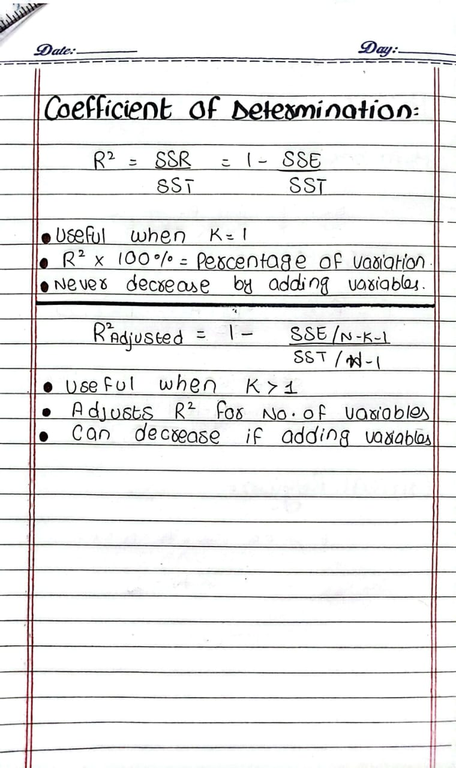

EXAMPLE: Test whether the overall regression model is statistically significant at the 5% level.
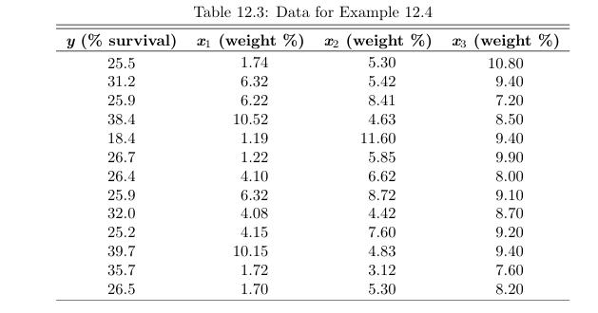
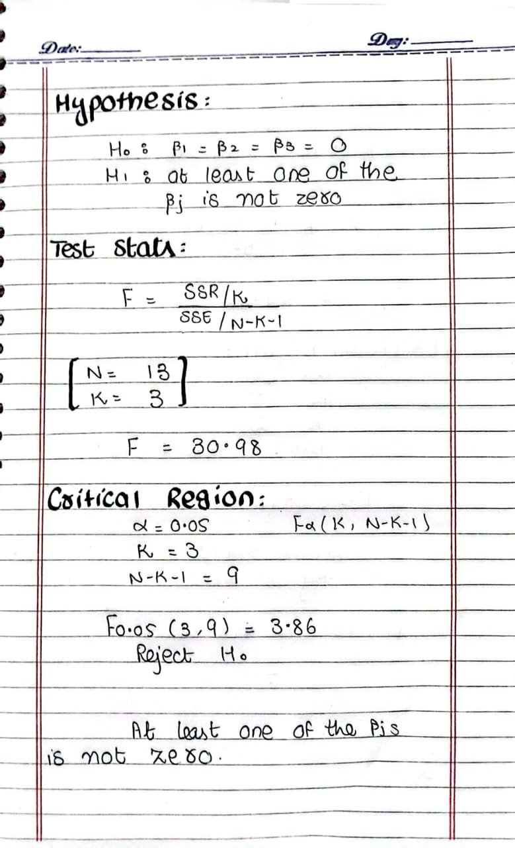

EXAMPLE: Using the F-test, determine whether the variables X2 and X3 significantly contribute to the model. Use α=0.05
ERROR:
V2 = N-K-1 = 13-3-1
